**EXPERIMENT NO. 9**

Aim: To prepare Risk Mitigation, Monitoring and Management Plan (RMMM).

Problem Statement: To prepare RMMM plan for E-Commerce Shopping Website.

Theory:

R.M.M.M stands for risk mitigation, monitoring and management. There are three issues in strategy for handling the risk is

* Risk Avoidance
* Risk monitoring
* Risk management

Risk Mitigation:

* Risk mitigation means preventing the risk to occur  (Risk Avoidance). Following are the steps to be taken for mitigating the risks.
* Communicate with the concerned staff to find of probable risk.
* Find out and eliminate all those causes that can create rick before the project starts.
* Develop a policy in an organization which will help to continue the project even though some staff leaves the organization.
* Everybody in the project team should be acquainted with the current development activity.
* Maintain the corresponding documents in timely manner. This documentation should be strictly as per the standards set by the organization.
* Conduct timely reviews in order to speed up the work.
* For conducting every critical activity during software development, provide the additional staff if required.

Risk Monitoring:

* In risk monitoring process following things must be monitored by the project manager..
* The approach of the team members as pressure of project varies.
* The degree in which the team performs with the spirit of "team-work".
* The type of co-operation among the team members. The types of problems that are occurring. Availability of jobs within and outside the organization.
* The project manager should monitor certain mitigation steps. For example: If the current development activity is monitored continuously then everybody in the team will get acquainted with current development activity.
* The objective of risk monitoring is to check whether the predicted risks really occur or not. To ensure the step defined to avoid the risk are applied properly or not. To gather the information which can be useful for analysing the risk.

Risk Management:

[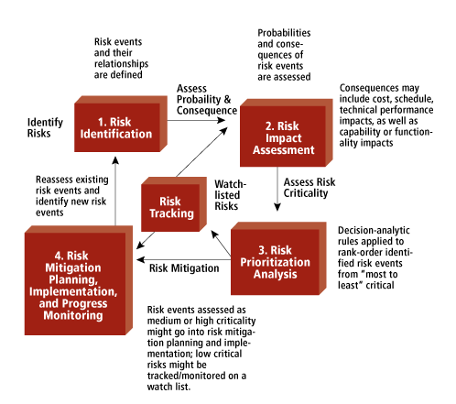](https://2.bp.blogspot.com/-NCpPsBUova8/Wa5ql7NYcnI/AAAAAAAAAP0/MJJhups4MxEH2_EwYqGVIWq36U9X9w24QCEwYBhgL/s1600/ase-rm-fig1.gif)

* Project manager perform this task when risk becomes a reality. If project manager is successful in applying the project mitigation effectively then it becomes very much easy to manage the risks.
* For example, Consider a scenario that many people are leaving the organization then  if sufficient additional staff is available, if current development activity is know to everybody in the team, if latest and systematic documentation is available then any 'new comer' can easily understand current development activity. This will ultimately help in continuing the work without any interval.

Risk Plan:

The R.M.M.M plan is a document in which all the risk analysis activities are described. Sometimes project manager includes this document as a part of overall project plan. Sometimes specific R.M.M.M plan is not created, however each risk can be described individually using risk information sheet.

RMMM Plan for E-commerce website:

E-Online Security:

Risk Mitigation:

1. Phishing
2. Data error
3. Credit card fraud
4. Hacking

Risk Management:

1. Multi-Layer security
2. Monitor all transaction
3. Deploy PCI scan
4. Get trust marked with SSL certificate

Customer disputes and chargebacks:

There are several customer disputes which arises time to time from ordering delivery.

Risk Mitigation:

1. Product never arrived
2. Didn’t meet expectation
3. Didn’t match as website describe.
4. Delivery of wrong product.

Risk Management:

1. Keeping track of product
2. Not to charge until shipped
3. Clear refund policy
4. Full authorization for order before shipping.

Product Warehouse & Logistic:

Risk Mitigation:

Running high performance app warehouse operation and logistics can be tricky and if it is not done right, it can result in time, money and customer satisfaction going down the drain.

1. Run out of stock in warehouse when orders come in.
2. Product shipment delayed.
3. Misdelivery.

Risk Management:

1. Stock management: Use inventory system
2. Barcode scanner to speed up process.
3. Ensure proper order tracking to customer.
4. Cross check whether the right delivery details are entered.
5. If package was misdelivered, check the receipt’s sign and address and ensure it is delivered to right location, otherwise process the refund.

Customer Service:

Risk Mitigation:

* Reviews, services, culture, social media and negative PR.

Risk Management:

* Provide chat box, personalization, respond to customer complaints quickly and gracefully.

Conclusion: We have successfully understand the concept of RMMM plan and prepared RMMM plan for E-Com. Website.